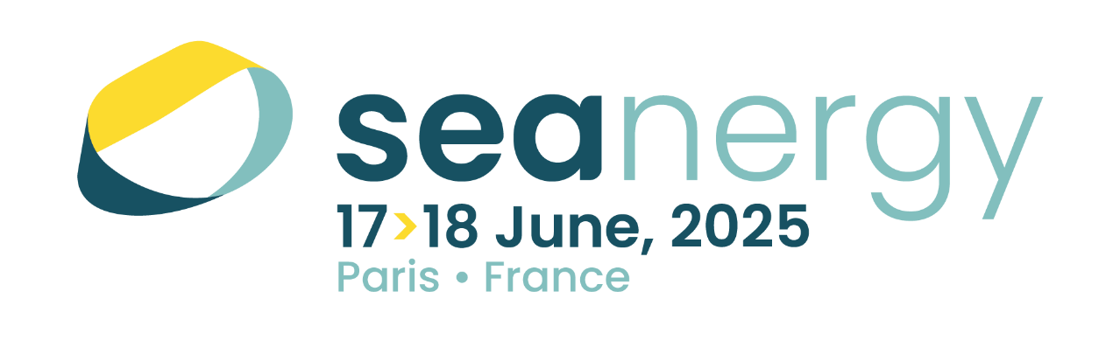
您好，
法國最重要的海洋再生能源展Seanergy 2025將於2025年6月17至18日於巴黎Porte de Versailles展覽館舉行。
做為歐洲最重要的離岸再生能源交流平台之一，Seanergy 連結全球海洋再生能源產業相關企業，促進合作、展示創新，並加速能源轉型。展會焦點涵蓋多種技術例如浮動式風力發電、潮汐能、波浪能、海洋溫差能（SWAC & OTEC）、浮動式太陽能（FPV）、鹽差發電以及相關產業如儲能、低碳航運（風力 & 氫能）、無人機應用、環境相容生態材料等。
為何2025 Seanergy不容錯過 —
- 一個真正國際化的平台：歷年展會已吸引超過3,500人觀展及超過200個參展單位，其中30%為外國企業。Seanergy提供難得的交流網絡與尋找合作夥伴的機會。
- 市場洞察與策略：從最新技術發展成果、全球離岸能源專案面臨的挑戰與成功案例中獲取全方位的產業視角。
- 歐洲與全球鏈結：歐洲引領離岸能源開發的同時，Seanergy亦強調全球的商機，串連市場、決策者以及先驅者。
離岸再生能源領域發展迅速，世界各國政府均制定雄心勃勃的目標來擴大開發規模。以法國為例，其 AO10 標案和 2035 年建置18 GW 目標等計畫，可視為通往廣大歐洲市場的門戶。透過參與Seanergy 2025，貴公司將身處全球離岸再生能源生態系的核心，並與重要產官學研單位鏈結。
更多資訊請見Seanergy官網：https://www.seanergy-forum.com/
Searnergy 2025 期待與您在巴黎相會！

Greetings,
Seanergy 2025, France’s international event on offshore renewable energy, will take place from June 17th to 18th 2025 in Paris Porte de Versailles Exposition Hall.
As one of Europe’s most significant hubs for offshore renewables, Seanergy connects stakeholders from across the globe to foster collaboration, showcase innovations, and accelerate the energy transition.
Seanergy is a cross-technology event, covering fixed and floating wind power, tidal energy, wave energy, marine thermal energy (SWAC & OTEC), floating solar power (FPV), salinity gradients energy and related industries such as: energy storage, digital decarbonization maritime transports (wind-powered & hydrogen), drones or eco-designed materials, etc.
Here’s why Seanergy 2025 is the essential event for your business:
- A truly international platform: With 3,500+ participants and 200+ exhibitors from Europe and beyond, Seanergy offers unparalleled networking and partnership opportunities.
- Market insights and strategies: Gain a 360° view of the industry, from the latest technological advancements to challenges and success stories shaping global offshore projects.
- European leadership and beyond: While Europe leads the way in offshore development, Seanergy highlights opportunities worldwide, connecting markets, decision-makers, and pioneers.
The offshore renewable energy sector is evolving rapidly, with governments worldwide setting ambitious targets to scale up projects. France, for instance, is gaining momentum, with initiatives like the AO10 tender and 18 GW target by 2035, offering gateways to broader European market opportunities. By participating in Seanergy 2025, you position your company at the heart of this growing global network, gaining visibility among key players and potential partners.
We look forward to welcoming you at Seanergy 2025 in Paris !

聯繫窗口Contact：Promosalons Taiwan - 法國在台協會商務處 (Business France Taiwan)
工業組專員Astrid CHEN小姐
電子信箱Email : astrid.chen@businessfrance.fr
電話Phone：+886 965 150 591

